Here is the **stretched** activity trace with duration:

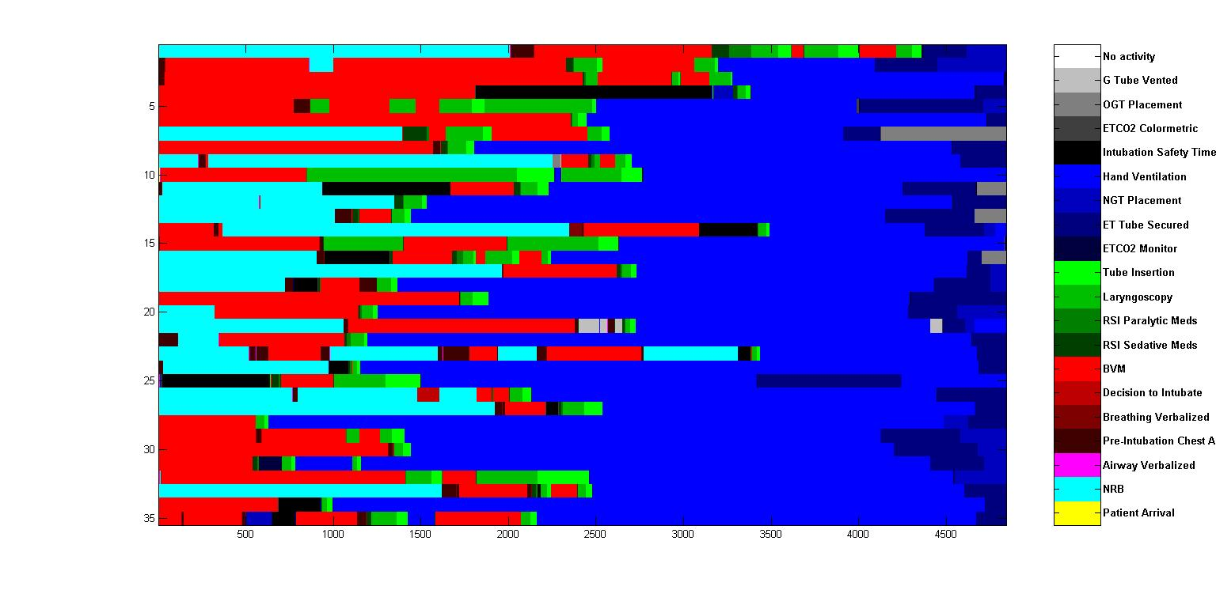

Figure 1

(each block represents **1 second**)

Here is the **unstretched** activity trace with duration:

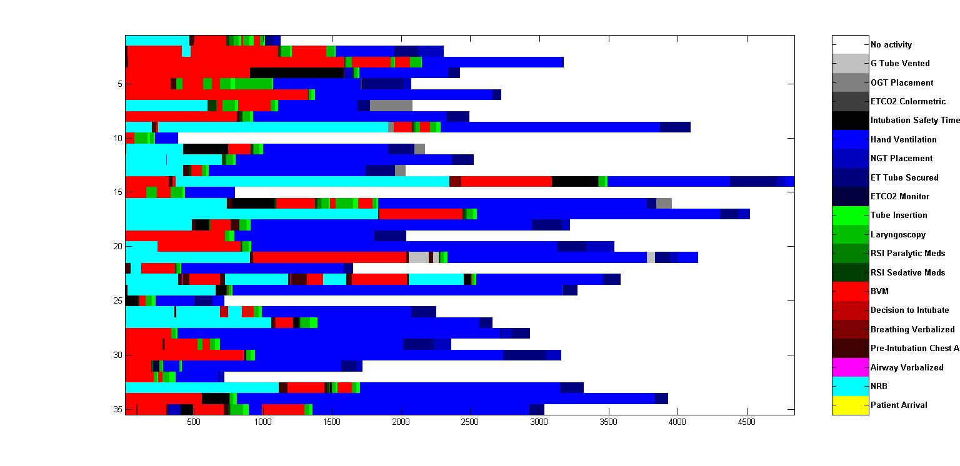

Figure 2

(each block represents **1 second**)

**Histograms of locations for all activities**

Here are the histograms of locations for all activities **without duration:**

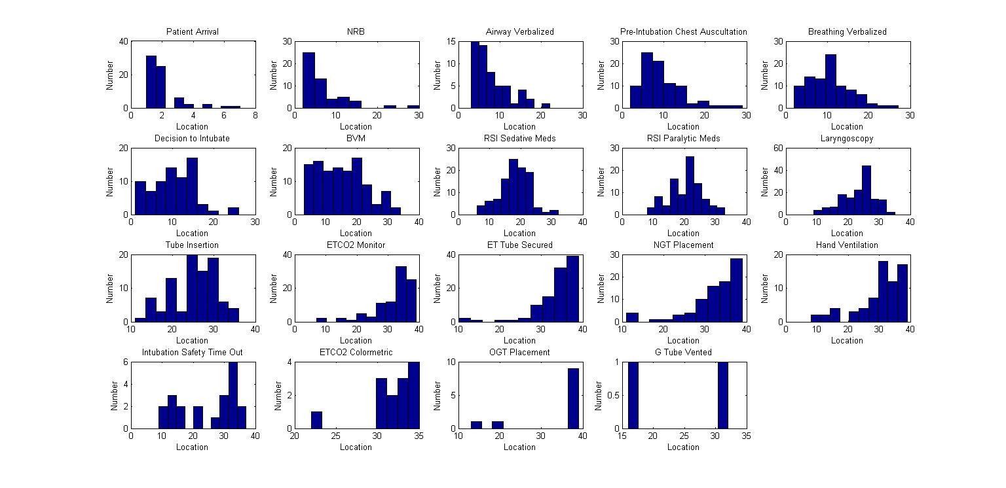

Figure 3

Here are the histograms of locations for all activities **with duration:**

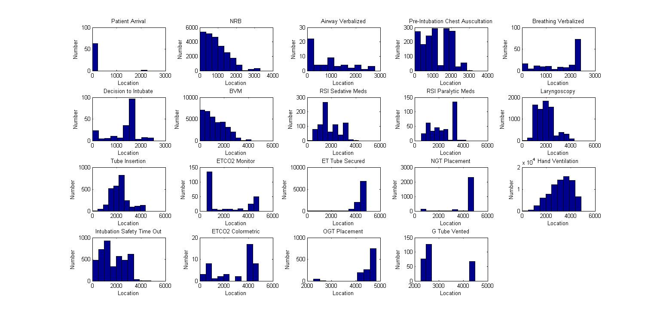

Figure 4

**Histograms of durations for all activities**

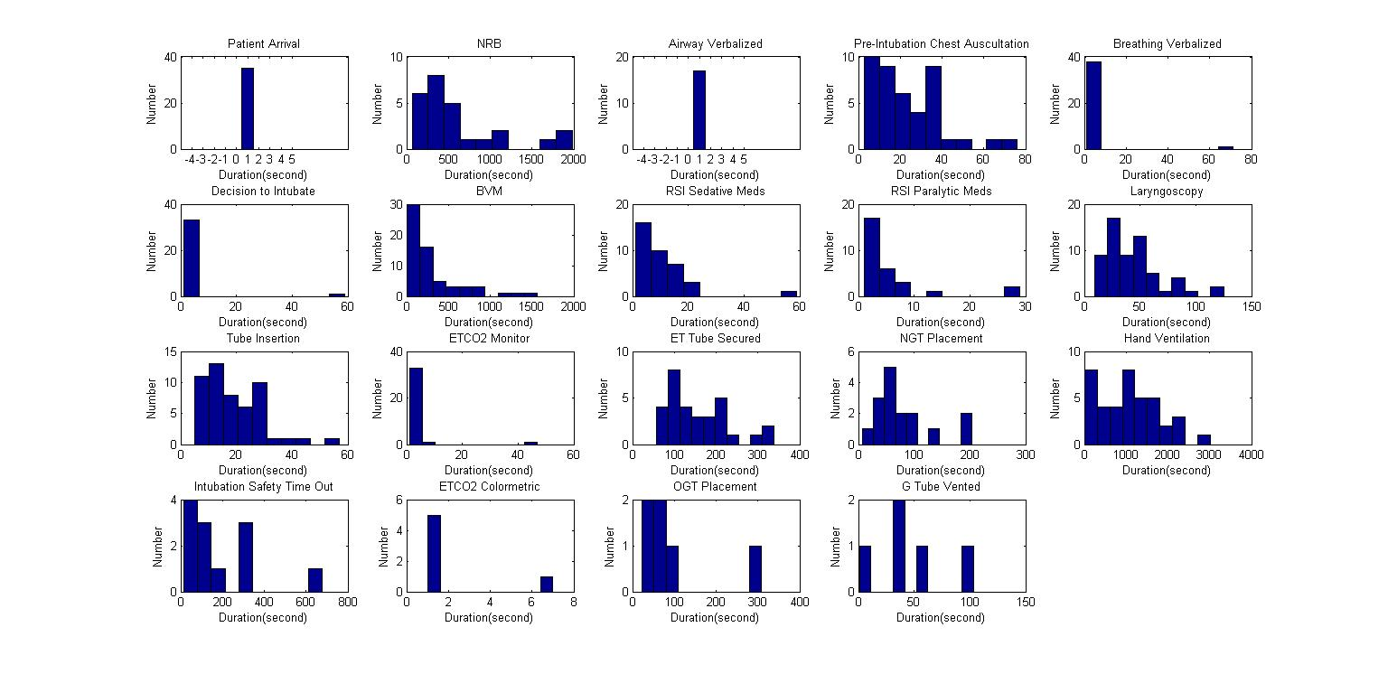

Figure 5

**Analysis**

Compare the two sets of histograms of location in figure 3 and figure 4, some activities histogram of location shows much visible difference. It is because in those activities, one of the occurrences takes a much longer duration than the others. Then in the histogram with duration, that occurrence of activity with longer duration would occupy a majority of blocks number.

Take *ETCO2 Monitor as an example*, almost all of the occurrence last for 1 second but one occurrence (near location#10) lasts for 42 seconds. So that occurrence makes the majority of the blocks number in the histogram of location with duration.

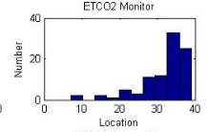

Location histogram without duration

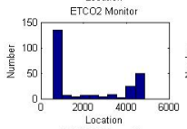

Location histogram with duration

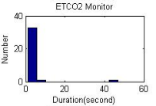

Duration histogram

Compare the histogram of duration to the histogram of location in Figure 5 and Figure 3, it shows that the “parallel” activities (don’t have discernible peak) may mostly occur very quickly. For example,

